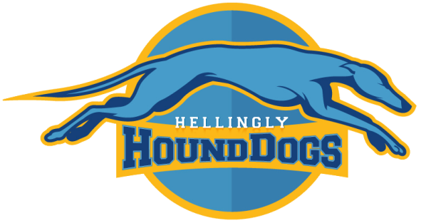
Hellingly Hound Dogs American Football Organisation
Parental Consent Form 2018

Declaration

I _____________________________________ wish my son/daughter to participate in American Football activities planned by and conducted by the Hellingly Hound Dogs American Football Organisation. All club sessions are run under the guidance of coaches qualified to the appropriate British American Football Association/British American Football Coaches Association/USA Football level and in accordance with the Organisations Child Protection Policy

Player Details

Surname |  |  |  | Forename(s)
Address
Postcode
Telephone (Home) |  |  | Telephone (Mobile)
Emergency Contact |  |  | Relationship
Emergency Contact Telephone Number
Parental E-mail Contact

Date Of Birth |  | Age |  | Nationality
Pervious Sporting Experience –

Medical Information

Doctor |  | Telephone Number
Doctors Address –

Any Ongoing Medical Conditions?

Do You Have Any Allergies?

Please Note That Participation WILL NOT BE ALLOWED Until This Form Is Completed, Signed and Returned
Consent (Please Read Carefully)

I hereby give permission for my Son/Daughter to participate in Hellingly Hound Dogs American Football activities during the 2016 season.
I understand that if those activities involve away travel and/or overnight trips I will be given prior notice and be asked for consent in advance of these activities.
I understand that it is my responsibility to arrange travel to or from organized activities and that should I require a member of Hellingly Hound Dogs American Football Organisation to collect/drop off my child I will need to provide separate consent for this.
I confirm to the best of my knowledge that my son/ daughter does not suffer from any medical condition other than those listed above.
I understand that the Club or Organisers accept no responsibility for loss, damage or injury caused by or during attendance on any of the clubs organised activities except where such loss, damage or injury can be shown to result directly from the negligence of the Club or the Organisers.
I agree to my child being photographed or filmed for publicity, public relations or coaching purposes during the course of their involvement with our organization and understand that any images/video footage will be used in compliance with the Data Protection act and our Child Protection Policy.

Print Name
Signature
Date |  | Relationship

Medical Consent

I give Hellingly Hound Dogs American Football Organization permission to provide treatment or authorize treatment of an injury or illness where such injury or illness has been assessed and treatment deemed necessary by a qualified first aider or medical personnel. This includes treatment including blood transfusions or anesthetic. This authorization is granted only if I am unable to be contacted and after reasonable efforts to do so have been made.
(Note – The medical profession takes the view that the parent’s consent to medical treatment cannot be delegated, this view is explicit on the Child act 1989. Thus medical consent forms have no legal status and a doctor/nurse insisting on the consent of a parent to a particular treatment has the right to do so. For this reason we do not recommend insistence on parents signing the statement above. However it can be a comfort to medical staff to have general consent in advance from parents or to have an adult on hand to sign forms required by medical authorities.)

Print Name
Signature
Date |  | Relationship

Photograph Consent

I give Hellingly Hound Dogs American Football Organisation permission for my child to have his/her photograph taken as part of any individual or team photographs and for these photographs to be used and reproduced by Hellingly Hound Dogs American Football Origination in such a manner, as they deem appropriate. Usage will be used in guidelines set out in the club’s Child Protection Policy.

Print Name
Signature
Date |  | Relationship

